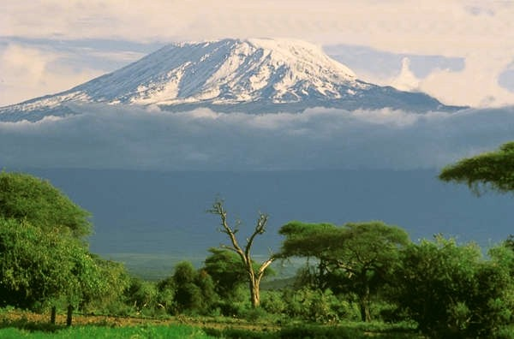

Soon my mum will be travelling to Africa to climb Mt Kilimanjaro and go on a Safari to raise money for a school of underprivileged yet very bright and enthusiastic children. This is why I’m doing this fundraiser. My Mum and I are creating a giant wall hanging, called:
“Handprints From Somerset”

Here, at 1pm on Tuesdays and Wednesdays, I will be setting up near the year 6 classrooms, and for a donation of $2, you can paint your hand and place it on the sheet then write your name next to it. My Mum will then take the finished artwork with her to Africa, where it will be displayed in their classrooms for all time…a friendly “Hello” from the students of Somerset! Money raised from this will enable them to buy things like:

Pens and pencils
Books
Chalk
Markers,
And even just socks!
The list of what they need just goes on and on…

So remember…
Have fun,
Get dirty,
And make your mark!

